MEDIA ALERT: Xytech to Officially Launch MediaPulse 10 with Series of Webinars
The 4-day webinar series will be held Oct. 26-29th and cover the upgrades to MediaPulse version 10

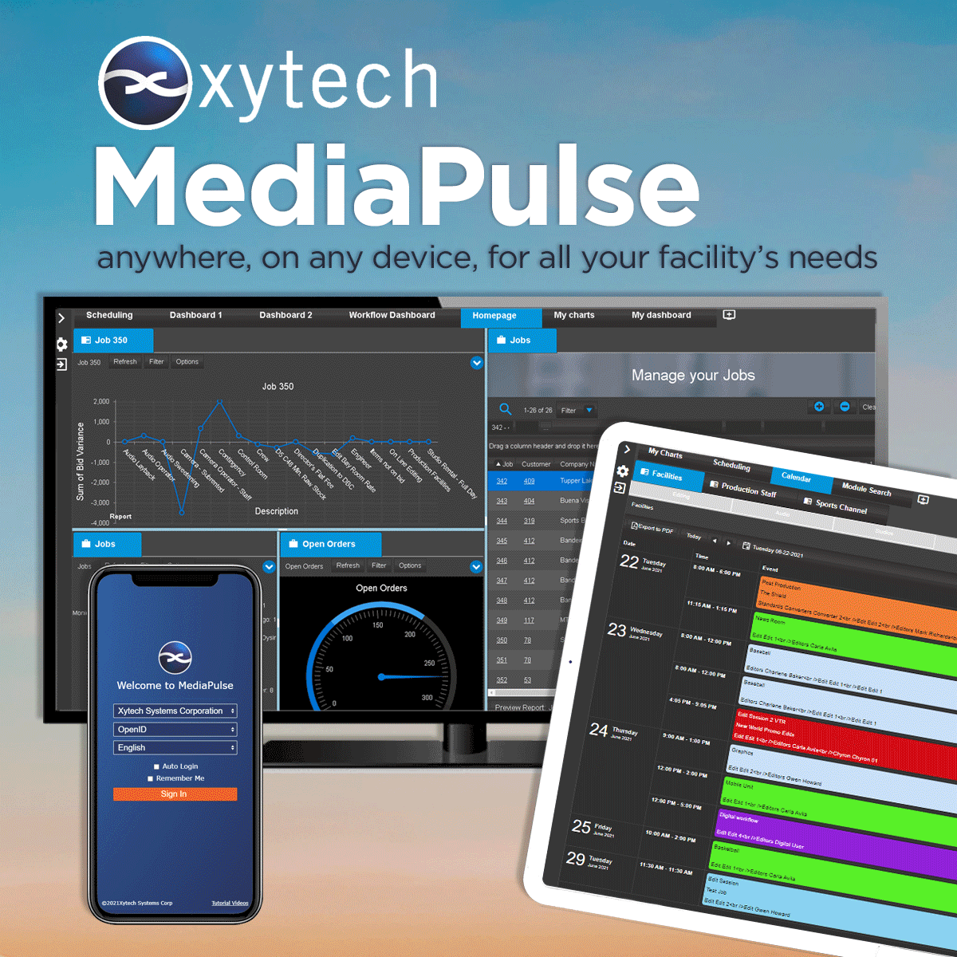
Los Angeles, October 12, 2021 — Xytech, the leader in resource management software for the broadcast and media industries, will host a 4-day webinar series from Oct. 26–29th showcasing the upgrades to MediaPulse 10. Each day of the series will focus on a different feature of the system with Oct. 26–27 featuring a MediaPulse Overview, Oct. 27–28 showcasing MediaPulse Personnel and Oct. 28–29 highlighting MediaPulse Transmission.

“Until we can once again meet in person, these webinar series are essential communication tools to the community. This begins a conversation where we inform customers of the advances of the product and help us to understand where our platform needs to be in the future,” said Greg Dolan, Xytech’s CCO. “With the version 10 update, MediaPulse provides every user with exactly the functionality they need, when they need it, on the device of their choosing, creating a reliable solution able to operate anywhere. Something the pandemic has made crucial.”

MediaPulse Overview
On Oct. 26, Xytech will host two webinars at 1pm BST, to accommodate European attendees, and at 1pm EST/10am PST, to accommodate North and South American attendees. A third webinar will be held at 10am AEST on Oct. 27 for Australian/MEAU attendees.

During this first webinar, attendees will learn how MediaPulse 10 simplifies scheduling, automation, asset management, billing and cost recovery for broadcasters, media services companies and transmission facilities in a scalable platform-independent solution. Learn how to efficiently crew your facilities, events and productions, while interfacing with your financial system to track costs and bill clients.

MediaPulse Personnel
To be held on Oct. 27 at 1pm BST and 1pm EST/10am PST and on Oct. 28 at 10am AEST, this webinar will showcase the upgrades to the MediaPulse 10’s Personnel Management features.

MediaPulse manages all aspects of a company’s personnel scheduling needs. The solution’s intuitive tools quickly set rosters, assigns tasks, communicates schedules and records actualized time with just a few clicks. Our payroll rules engine computes in real-time any potential payroll violations and their cost implications offering alternative staff for each position on a roster.

MediaPulse Transmission
The final webinar in the series will be held Oct. 28 at 1pm BST and 1pm EST/10am PST and on Oct. 29 at 10am AEST and focus on MediaPulse 10’s Transmission module.

The world’s premier broadcasters rely on MediaPulse Transmission to ensure smooth operation through automated feed management, device automation, bandwidth utilization and accurate billing all delivered in any browser on any device connected. Join this webinar to experience the difference MediaPulse can make to your facility. This webinar is a perfect fit for anyone interested in solving transmission issues.

To register for any of the MediaPulse 10 Webinar Series, please visit:
https://www.xytechsystems.com/webinar/

About Xytech
For more than 30 years, the world’s premiere media companies have depended on Xytech to run their businesses. MediaPulse is the only end-to-end solution for the complete content lifecycle. MediaPulse provides scheduling, automation, asset management, billing and cost recovery for broadcasters, media services companies and transmission facilities in a scalable platform-independent solution. In April 2021, Xytech acquired the ScheduALL brand of enterprise resource management software for broadcasters and media companies, providing end-users with an even more robust product roadmap and greater global service offerings. For more information, visit xytechsystems.com.

Media Contacts:

Katie Kailus
Public Relations
Hummingbird Media
+1 (630) 319-5226
katie@hummingbirdmedia.com

Jeff Touzeau
Public Relations
Hummingbird Media
+1 (914) 602 2913
jeff@hummingbirdmedia.com

